- FOR COPYING FILES FROM ONE FOLDER TO ANOTHER FOLDER

cd /d "d:\snaps\2016" (FILES COPING DIRECTORY)
for /r %d in (*) do copy "%d" "d:\My pictures"` (COPY TO DIRECTORY)

- TO FILTER ONLY PDF FILES
get-ChildItem F:\Reports\govOrganizationReports\* -Include *.pdf -Recurse

- To Delete only PDF files
get-ChildItem F:\Reports\govOrganizationReports\* -Include *.pdf -Recurse | foreach { Remove-Item -Path $_.FullName }

- TO GET INTO PATH
Cd Desktop\SD-EMDB\BENEFIT (location of the files)
Ls(to list the available files)

- TO ADD THE PREFIX IN ALL FILE IN PARTICULAR FOLDER
dir | where-object -filterscript {($_.name-like 'Daily*')} | Rename-item -newname {('EMDB_'+$_.NAME)}

- TO SWAP THE LOCATION OF DIRECTORY
set-location C:\Users\e5603809\Desktop\SD-EMDB\CARD

- TO RENAME FILES IN PARTICULAR FOLDER
dir | where-object -filterscript {($_.name-like 'EMDB*')} | Rename-item -newname {($_.name -replace "ATM","POS")}

- TO find the string in the group of files
Get-ChildItem -recurse | Get-Content | Select-String -pattern "dummy"

- To Combine multiple files into single file
Get-Content inputFile*.txt | Set-Content joinedFile.txt
get-content 'EMDB*.txt'| Set-content POS.txt

- Copy items
get-Childitem -path \\vwmazdvebtap02\Reports\govOrganizationReportsMirror\ |Copy-item -Destination \\vwmazdvebtap02\Reports\govOrganizationReports\ -Recurse

- To Run all the sql scripts at same time

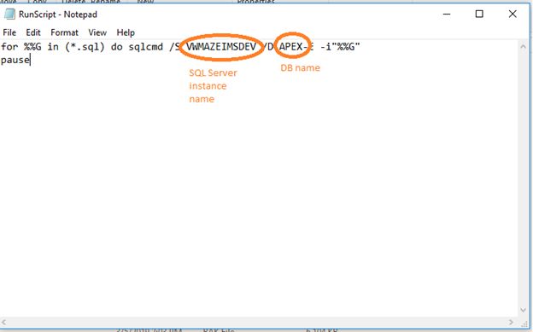

- To export the list of reports available in particular foder

dir "C:\Windows" /a /s /b >j.txt

Dir- keyword

"c:\windows" - path in which we are going to export the text file with list
/a - all files

/s - includes subfolder
/B Uses bare format (no heading information or summary).
<https://stackoverflow.com/questions/15214486/command-to-list-all-files-in-a-folder-as-well-as-sub-folders-in-windows>

